Day 03 Task

Q1. Problem Statement:
Think of yourself as a counsellor who is responsible for suggesting students a right career option. For this you want some information which you must note in excel. Your task is to:
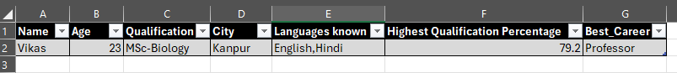
- Create a range of students’ data in excel having 20 records with at least 6 fields that are important according to you. After all fields create another field in the range where you as a counsellor think what career option is best. Example:
*Note*: It is for example purpose try not to copy same fields.
- Create a document mentioning the objective, data points, and why did you choose the variables.
- Also create a description table for each variable on a different sheet in the same workbook.

Task 1 – Core Formula Practice
Dataset link: https://mega.nz/file/VF9jRALD#N57_PCfK8V6hvsmVIbnjfvdOnTdQw7YrcPDlT-czCAU

Using the given dataset, apply the following formulas (at least once each):
- SUM
- AVERAGE
- COUNT
- MAX
- MIN
Create a separate sheet named Formula_Practice and place all calculations there.

Task 2 – Logical Column Creation (IF Function)
Create a new column named Performance_Flag with the following logic:
- If Purchase Amount > Average Purchase Amount → High
- Else → Low
(Formula must be used, no manual tagging.)

Task 3 – Formula Explanation
Pick any two formulas you used today and answer:
- Why was this formula required?
- What business meaning does the output give?
(Answer in 3–4 lines each.)

Task 4 – Excel Error Identification
For each error, write:
- Error name
- Why it occurred
- How you corrected it

Task 5 – Mini Check Questions
- What is the difference between COUNT, COUNTNA, and COUNTA?
- Why should calculations never be done manually in Excel?
- What happens if we copy a formula without understanding cell references?

Submission Instructions
- Submit one Excel file with formulas visible
- Written answers can be in the same file or a separate document
- Do not remove raw data

